
Fall 2020 Virtual Dance Film Production

Dancers of all levels and backgrounds are invited to be a part of this unique
dance film experience
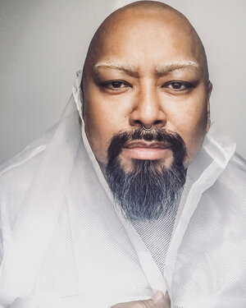

The
T
MIKE ESPERANZA

A VISION BEHIND the LENS
For more information contact  alduenda_leann@sac.edu or gillette_heather@sac.edu |  | Santa Ana College  Dance Department  The Body REveals  A virtual Dance Film Event  December 2, 2020 @ 7:30pm
  Santa Ana College  Fine & Performing Arts | Sponsored by  FeelitLive!
Mike’s work has been described as “bold, athletic movement and theatricality – the latter clearly the coming together of Esperanza’s many talents – the company epitomizes the dance of the new millennium: shape-shifting, vernacular-blending with a prescient focus on the brave new world in which we live.” ~ Jessica Abrams, Explore Dance.

Street
Street

Street

Take advantage of this special opportunity to be a part of this SAC Dance Repertory event, directed by leading New York dance film maker, Mike Esperanza! Choreography will be created by SAC dance faculty, with students and faculty guided under Mike Esperanza’s directorship and dance film-making expertise. *REGISTER NOW to be a part of this exclusive event!

gillette_heather@sac.edu
alduenda_leann@sac.edu
sac.edu/dance
Dance Film Premiere | December 2, 2020 | Sponsored by FeelitLive!
  HAPPENING NOW!
  AUDITION INFORMATION
  Auditions will be held during a series of ConferZoom meetings made available starting Monday, August 24 - Friday, September 25.
  CONTACT:
  alduenda_leann@sac.edu
  or
  gillette_heather@sac.edu
  to register for a
  ConferZoom invite for the pre-screening audition process.
  HAPPENING NOW!
  Registration Information
  All dancers accepted into the dance film project must register for one of the following courses:
  - DNCE 107 Dance Concert Performance
  section #90408
  - DNCE 240A Repertory I section #88157
  - DNCE 240B Repertory II
  section #88160
  - DNCE 240C Repertory III section #88161
  - DNCE 240D Repertory IV section #88164
  All dancers must also register for one of the following courses:
  - DNCE 009A LAB I section #88086
  - DNCE 009B LAB II section #88087
  - DNCE 009C LAB III section #88088
  - DNCE 009D LAB IV section #88089
  HAPPENING NOW!
  CONTACT INFORMATION
  Sign up for the audition process by contacting:
  alduenda_leann@sac.edu
  or
  gillette_heather@sac.edu
  Register for a
  ConferZoom invite for the
  pre-screening audition process.
  REGISTER NOW!
Street
Street
Street
Street

